[**https://www.milenio.com/negocios/inaes-9-1-millones-micronegocios-mexico**](https://www.milenio.com/negocios/inaes-9-1-millones-micronegocios-mexico)

KAREN GUZMÁN

**Ciudad de México / 27.08.2019 17:05:54**

En México existen 9.1 millones de micronegocios, de los cuales más del 80 por ciento están integrados por un dueño y un trabajador, de acuerdo con datos del Instituto Nacional de la Economía Social (Inaes) de la [Secretaría del Bienestar](https://www.milenio.com/buscador?text=secretaria+de+bienestar), por lo que buscan que el sector se consolide para beneficio de más personas.

Humberto Cerdio, coordinador de fomento y desarrollo empresarial del Inaes, mencionó que de los micronegocios, el 21.6 por ciento están integrados por tres personas incluido el dueño; 7.51 por tres trabajadores y el dueño; mientras que el 0.03 por ciento tienen entre 10 y 15 trabajadores

En el marco de la cuarta reunión de cooperativas populares organizada por Prybe, el directivo mencionó que el 68 por ciento de los micronegocios no cuentan con un local propio y fueron establecidos principalmente por propietarios que buscaban incrementar sus ingresos mensuales, por tradición familiar o bien, falta de empleo.

“No se tiene un local, los dueños de puestos, taquerías o negocios pequeños trabajan en sus casas o en un puesto en la calle porque en términos generales no se tienen los recursos para comprar o rentar un local en las zonas donde existen los clientes, por lo que no tiene los elementos para crecer”.

En tanto, Cerdio agregó que el 60 por ciento de los negocios micronegocios en México no son nuevos, tienen más de cinco años de antigüedad y sus dueños se encuentran entre los 40 y los 49 años. Además, destacó que 1.5 millones de personas de la tercera edad tienen algún negocio personal.

“De los micronegocios en términos generales no generan las condiciones de bienestar que se busca al emprender y otro factor es la falta de la economía de escala porque se trabaja de manera individual en lugar de trabajar en grupo”, indicó.

[**http://www.2006-2012.economia.gob.mx/mexico-emprende/empresas/microempresario**](http://www.2006-2012.economia.gob.mx/mexico-emprende/empresas/microempresario)

Las microempresas son todos aquellos negocios que tienen menos de 10 trabajadores, generan anualmente ventas hasta por 4 millones de pesos y representan el 95 por ciento del total de las empresas y el 40 por ciento del empleo en el país; además, producen el 15 por ciento del Producto Interno Bruto.

De acuerdo al último Censo Económico publicado por el Instituto Nacional de Estadística y Geografía (INEGI), del universo de unidades económicas en México:

a) el 95.2% son microempresas

b) generan el 45.6% del empleo

c) contribuyen con 15% del valor agregado de la economía

<https://www.jalisco.gob.mx/es/jalisco/municipios/tamazula-de-gordiano>

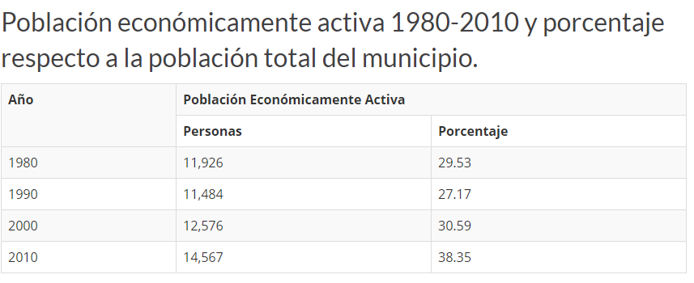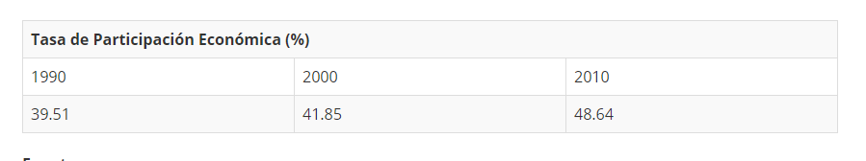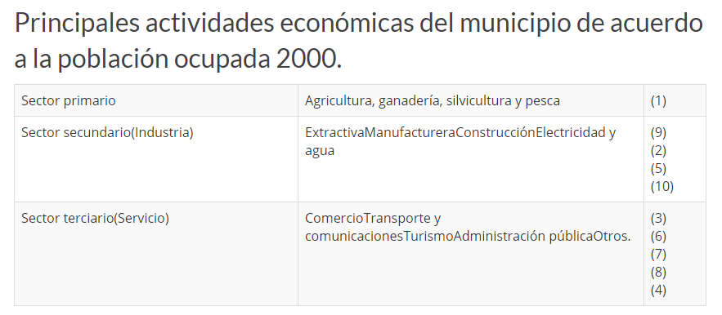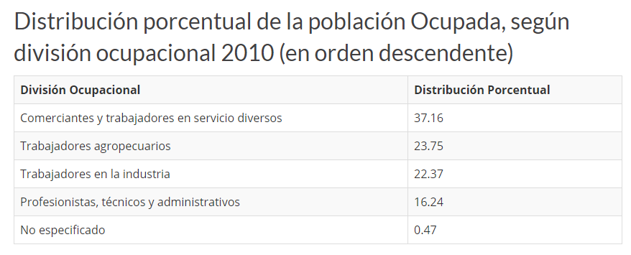

<https://iieg.gob.mx/contenido/Municipios/TamazuladeGordiano.pdf>

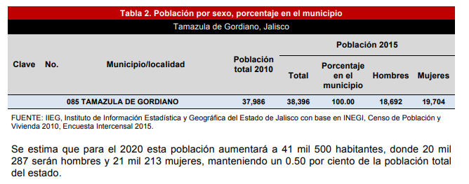

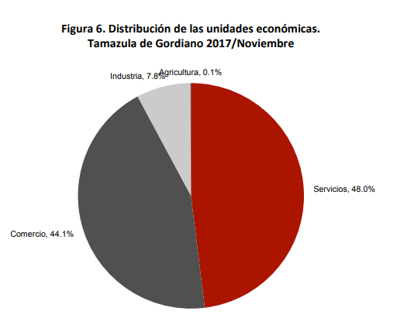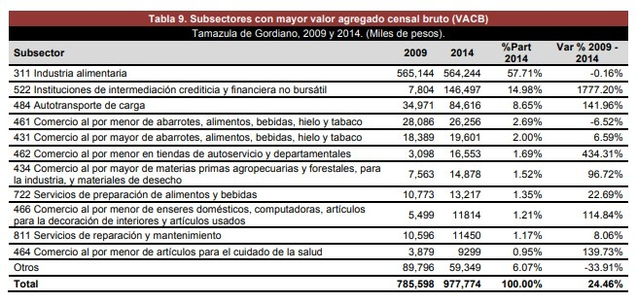

<http://www.tamazuladegordiano.gob.mx/new/transparencia2/articulo8/articulo8-5.htm>

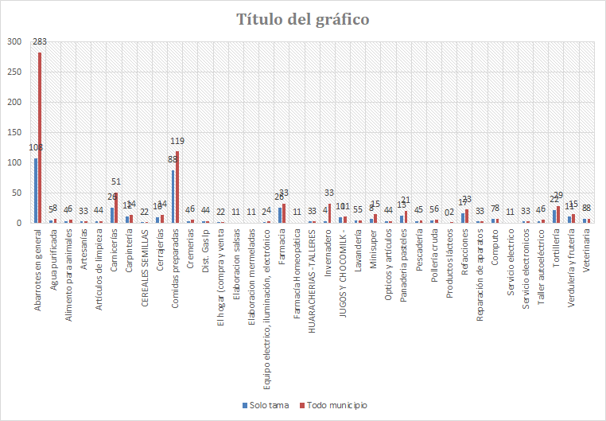

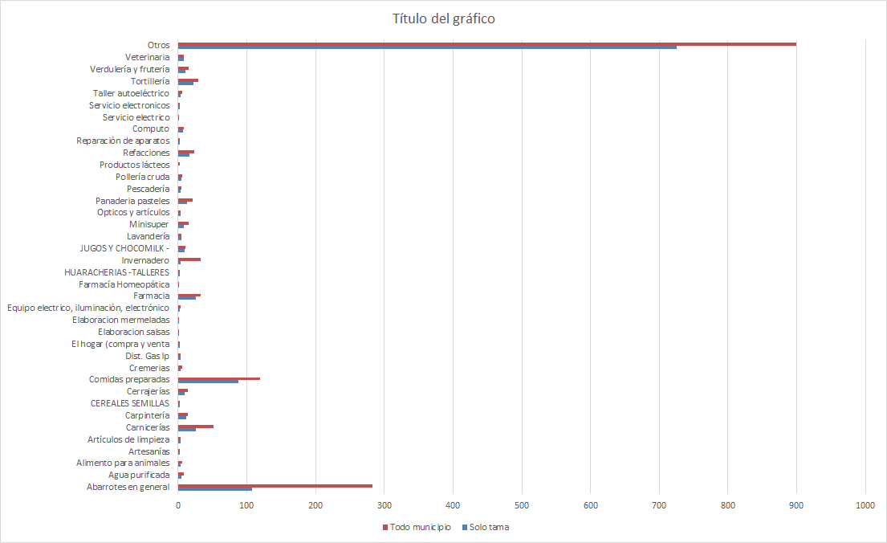

<http://cuentame.inegi.org.mx/monografias/informacion/jal/poblacion/default.aspx?tema=me%26e=14>

|  |  |  |  |  |  |  |  |  |  |  |  |  |  |  |  |  |  |  |  |  |  |  |  |  |  |  |  |  |  |  |  |  |  |  |  |  |  |  |  |  |  |  |  |  |  |  |  |  |  |  |  |  |  |  |  |  |  |  |  |  |  |  |  |  |  |  |  |  |  |  |  |  |  |  |  |  |  |  |  |  |  |  |  |  |  |  |  |  |  |  |  |  |  |  |  |  |  |  |  |  |  |  |  |  |  |  |  |  |  |  |  |  |  |  |  |  |  |  |  |  |  |  |  |  |  |  |  |  |  |  |  |  |  |  |  |  |  |  |  |  |  |  |  |  |  |  |  |  |  |  |  |  |  |  |  |  |  |  |  |  |  |  |  |  |  |  |  |  |  |  |  |  |  |  |  |  |  |  |  |  |  |  |  |  |  |  |  |  |  |  |  |  |  |  |  |  |  |  |  |  |  |  |  |  |  |  |  |  |  |  |  |  |  |  |  |  |  |  |  |  |  |  |  |  |  |  |  |  |  |  |  |  |  |  |  |  |  |  |  |  |  |  |  |  |  |  |  |  |  |  |  |  |  |  |  |  |  |  |  |  |  |  |  |  |  |  |  |  |  |  |  |  |  |  |  |  |  |  |  |  |  |  |  |  |  |  |  |  |  |  |  |  |  |  |  |  |  |  |  |  |  |  |  |  |  |  |  |  |  |  |  |  |  |  |  |  |  |  |  |  |  |  |  |  |  |  |  |  |  |  |  |  |  |  |  |  |  |  |  |  |  |  |  |  |  |  |  |  |  |  |  |  |  |  |  |  |  |  |  |  |  |  |  |  |  |  |  |  |  |  |  |  |  |  |  |  |  |  |  |
| --- | --- | --- | --- | --- | --- | --- | --- | --- | --- | --- | --- | --- | --- | --- | --- | --- | --- | --- | --- | --- | --- | --- | --- | --- | --- | --- | --- | --- | --- | --- | --- | --- | --- | --- | --- | --- | --- | --- | --- | --- | --- | --- | --- | --- | --- | --- | --- | --- | --- | --- | --- | --- | --- | --- | --- | --- | --- | --- | --- | --- | --- | --- | --- | --- | --- | --- | --- | --- | --- | --- | --- | --- | --- | --- | --- | --- | --- | --- | --- | --- | --- | --- | --- | --- | --- | --- | --- | --- | --- | --- | --- | --- | --- | --- | --- | --- | --- | --- | --- | --- | --- | --- | --- | --- | --- | --- | --- | --- | --- | --- | --- | --- | --- | --- | --- | --- | --- | --- | --- | --- | --- | --- | --- | --- | --- | --- | --- | --- | --- | --- | --- | --- | --- | --- | --- | --- | --- | --- | --- | --- | --- | --- | --- | --- | --- | --- | --- | --- | --- | --- | --- | --- | --- | --- | --- | --- | --- | --- | --- | --- | --- | --- | --- | --- | --- | --- | --- | --- | --- | --- | --- | --- | --- | --- | --- | --- | --- | --- | --- | --- | --- | --- | --- | --- | --- | --- | --- | --- | --- | --- | --- | --- | --- | --- | --- | --- | --- | --- | --- | --- | --- | --- | --- | --- | --- | --- | --- | --- | --- | --- | --- | --- | --- | --- | --- | --- | --- | --- | --- | --- | --- | --- | --- | --- | --- | --- | --- | --- | --- | --- | --- | --- | --- | --- | --- | --- | --- | --- | --- | --- | --- | --- | --- | --- | --- | --- | --- | --- | --- | --- | --- | --- | --- | --- | --- | --- | --- | --- | --- | --- | --- | --- | --- | --- | --- | --- | --- | --- | --- | --- | --- | --- | --- | --- | --- | --- | --- | --- | --- | --- | --- | --- | --- | --- | --- | --- | --- | --- | --- | --- | --- | --- | --- | --- | --- | --- | --- | --- | --- | --- | --- | --- | --- | --- | --- | --- | --- | --- | --- | --- | --- | --- | --- | --- | --- | --- | --- | --- | --- | --- | --- | --- | --- | --- | --- | --- | --- | --- | --- | --- | --- | --- | --- | --- | --- | --- | --- | --- | --- | --- | --- | --- | --- | --- | --- | --- | --- | --- | --- | --- | --- | --- | --- | --- | --- | --- | --- | --- | --- | --- | --- | --- | --- | --- | --- | --- | --- | --- | --- | --- | --- | --- | --- | --- | --- | --- | --- | --- | --- |
| |  |  |  |  |  |  |  |  |  |  |  |  |  |  |  |  |  |  |  |  |  |  |  |  |  |  |  |  |  |  |  |  |  |  |  |  |  |  |  |  |  |  |  |  |  |  |  |  |  |  |  |  |  |  |  |  |  |  |  |  |  |  |  |  |  |  |  |  |  |  |  |  |  |  |  |  |  |  |  |  |  |  |  |  |  |  |  |  |  |  |  |  |  |  |  |  |  |  |  |  |  |  |  |  |  |  |  |  |  |  |  |  |  |  |  |  |  |  |  |  |  |  |  |  |  |  |  |  |  |  |  |  |  |  |  |  |  |  |  |  |  |  |  |  |  |  |  |  |  |  |  |  |  |  |  |  |  |  |  |  |  |  |  |  |  |  |  |  |  |  |  |  |  |  |  |  |  |  |  |  |  |  |  |  |  |  |  |  |  |  |  |  |  |  |  |  |  |  |  |  |  |  |  |  |  |  |  |  |  |  |  |  |  |  |  |  |  |  |  |  |  |  |  |  |  |  |  |  |  |  |  |  |  |  |  |  |  |  |  |  |  |  |  |  |  |  |  |  |  |  |  |  |  |  |  |  |  |  |  |  |  |  |  |  |  |  |  |  |  |  |  |  |  |  |  |  |  |  |  |  |  |  |  |  |  |  |  |  |  |  |  |  |  |  |  |  |  |  |  |  |  |  |  |  |  |  |  |  |  |  |  |  |  |  |  |  |  |  |  |  |  |  |  |  |  |  |  |  |  |  |  |  |  |  |  |  |  |  |  |  |  |  |  |  |  |  |  |  |  |  |  |  |  |  |  |  |  |  |  |  |  |  |  |  |  |  |  |  |  |  |  |  |  |  |  |  |  |  |  | | --- | --- | --- | --- | --- | --- | --- | --- | --- | --- | --- | --- | --- | --- | --- | --- | --- | --- | --- | --- | --- | --- | --- | --- | --- | --- | --- | --- | --- | --- | --- | --- | --- | --- | --- | --- | --- | --- | --- | --- | --- | --- | --- | --- | --- | --- | --- | --- | --- | --- | --- | --- | --- | --- | --- | --- | --- | --- | --- | --- | --- | --- | --- | --- | --- | --- | --- | --- | --- | --- | --- | --- | --- | --- | --- | --- | --- | --- | --- | --- | --- | --- | --- | --- | --- | --- | --- | --- | --- | --- | --- | --- | --- | --- | --- | --- | --- | --- | --- | --- | --- | --- | --- | --- | --- | --- | --- | --- | --- | --- | --- | --- | --- | --- | --- | --- | --- | --- | --- | --- | --- | --- | --- | --- | --- | --- | --- | --- | --- | --- | --- | --- | --- | --- | --- | --- | --- | --- | --- | --- | --- | --- | --- | --- | --- | --- | --- | --- | --- | --- | --- | --- | --- | --- | --- | --- | --- | --- | --- | --- | --- | --- | --- | --- | --- | --- | --- | --- | --- | --- | --- | --- | --- | --- | --- | --- | --- | --- | --- | --- | --- | --- | --- | --- | --- | --- | --- | --- | --- | --- | --- | --- | --- | --- | --- | --- | --- | --- | --- | --- | --- | --- | --- | --- | --- | --- | --- | --- | --- | --- | --- | --- | --- | --- | --- | --- | --- | --- | --- | --- | --- | --- | --- | --- | --- | --- | --- | --- | --- | --- | --- | --- | --- | --- | --- | --- | --- | --- | --- | --- | --- | --- | --- | --- | --- | --- | --- | --- | --- | --- | --- | --- | --- | --- | --- | --- | --- | --- | --- | --- | --- | --- | --- | --- | --- | --- | --- | --- | --- | --- | --- | --- | --- | --- | --- | --- | --- | --- | --- | --- | --- | --- | --- | --- | --- | --- | --- | --- | --- | --- | --- | --- | --- | --- | --- | --- | --- | --- | --- | --- | --- | --- | --- | --- | --- | --- | --- | --- | --- | --- | --- | --- | --- | --- | --- | --- | --- | --- | --- | --- | --- | --- | --- | --- | --- | --- | --- | --- | --- | --- | --- | --- | --- | --- | --- | --- | --- | --- | --- | --- | --- | --- | --- | --- | --- | --- | --- | --- | --- | --- | --- | --- | --- | --- | --- | --- | --- | --- | --- | --- | --- | --- | --- | --- | --- | --- | --- | --- | --- | --- | --- | --- | --- | --- | --- | --- | --- | --- | --- | | |  |  |  | | --- | --- | --- | | **Clave del municipio** | **Municipio** | **Habitantes**  (año 2015) | | 001 | Acatic | 21 530 | | 002 | Acatlán de Juárez | 22 261 | | 003 | Ahualulco de Mercado | 23 362 | | 004 | Amacueca | 5 385 | | 005 | Amatitán | 15 344 | | 006 | Ameca | 60 951 | | 008 | Arandas | 77 116 | | 010 | Atemajac de Brizuela | 6 717 | | 011 | Atengo | 5 475 | | 012 | Atenguillo | 3 899 | | 013 | Atotonilco el Alto | 60 480 | | 014 | Atoyac | 8 264 | | 015 | Autlán de Navarro | 60 572 | | 016 | Ayotlán | 37 963 | | 017 | Ayutla | 12 453 | | 019 | Bolaños | 7 341 | | 020 | Cabo Corrientes | 10 303 | | 117 | Cañadas de Obregón | 4 110 | | 021 | Casimiro Castillo | 21 584 | | 030 | Chapala | 50 738 | | 031 | Chimaltitán | 3 383 | | 032 | Chiquilistlán | 6 102 | | 022 | Cihuatlán | 41 300 | | 024 | Cocula | 26 687 | | 025 | Colotlán | 17 865 | | 026 | Concepción de Buenos Aires | 6 088 | | 027 | Cuautitlán de García Barragán | 18 138 | | 028 | Cuautla | 2 120 | | 029 | Cuquío | 17 980 | | 033 | Degollado | 21 479 | | 034 | Ejutla | 1 862 | | 009 | El Arenal | 19 900 | | 037 | El Grullo | 24 312 | | 054 | El Limón | 5 379 | | 070 | El Salto | 183 437 | | 035 | Encarnación de Díaz | 53 555 | | 036 | Etzatlán | 19 847 | | 079 | Gómez Farías | 14 278 | | 038 | Guachinango | 4 184 | | 039 | Guadalajara | 1 460 148 | | 040 | Hostotipaquillo | 9 761 | | 041 | Huejúcar | 5 633 | | 042 | Huejuquilla el Alto | 8 787 | | 044 | Ixtlahuacán de los Membrillos | 53 045 | | 045 | Ixtlahuacán del Río | 19 070 | | 046 | Jalostotitlán | 33 777 | | 047 | Jamay | 24 753 | | 048 | Jesús María | 19 469 | | 049 | Jilotlán de los Dolores | 9 917 | | 050 | Jocotepec | 46 521 | | 051 | Juanacatlán | 17 955 | | 052 | Juchitlán | 5 638 | | 018 | La Barca | 65 055 | | 043 | La Huerta | 24 563 | | 057 | La Manzanilla de la Paz | 3 688 | | 053 | Lagos de Moreno | 164 981 | | 055 | Magdalena | 22 643 | | 058 | Mascota | 14 477 | | 059 | Mazamitla | 13 799 | | 060 | Mexticacán | 5 088 | | 061 | Mezquitic | 19 452 | | 062 | Mixtlán | 3 526 | | 063 | Ocotlán | 99 461 | | 064 | Ojuelos de Jalisco | 32 357 | | 065 | Pihuamo | 11 192 | | 066 | Poncitlán | 51 944 | | 067 | Puerto Vallarta | 275 640 | | 069 | Quitupan | 8 379 | | 071 | San Cristóbal de la Barranca | 3 117 | | 072 | San Diego de Alejandría | 7 349 | | 113 | San Gabriel | 16 105 | | 125 | San Ignacio Cerro Gordo | 18 952 | | 073 | San Juan de los Lagos | 69 725 | | 007 | San Juanito de Escobedo | 9 420 | | 074 | San Julián | 15 890 | | 075 | San Marcos | 3 783 | | 076 | San Martín de Bolaños | 3 122 | | 077 | San Martín Hidalgo | 27 777 | | 078 | San Miguel el Alto | 32 960 | | 098 | San Pedro Tlaquepaque | 664 193 | | 080 | San Sebastián del Oeste | 5 643 | | 081 | Santa María de los Ángeles | 3 033 | | 056 | Santa María del Oro | 2 028 | | 082 | Sayula | 36 778 | | 083 | Tala | 80 365 | | 084 | Talpa de Allende | 15 126 | | 085 | Tamazula de Gordiano | 38 396 | | 086 | Tapalpa | 19 506 | | 087 | Tecalitlán | 16 579 | | 089 | Techaluta de Montenegro | 3 703 | | 088 | Tecolotlán | 17 257 | | 090 | Tenamaxtlán | 7 005 | | 091 | Teocaltiche | 41 278 | | 092 | Teocuitatlán de Corona | 10 317 | | 093 | Tepatitlán de Morelos | 141 322 | | 094 | Tequila | 42 009 | | 095 | Teuchitlán | 9 608 | | 096 | Tizapán el Alto | 20 961 | | 097 | Tlajomulco de Zúñiga | 549 442 | | 099 | Tolimán | 10 310 | | 100 | Tomatlán | 35 824 | | 101 | Tonalá | 536 111 | | 102 | Tonaya | 5 960 | | 103 | Tonila | 7 919 | | 104 | Totatiche | 4 412 | | 105 | Tototlán | 23 171 | | 106 | Tuxcacuesco | 4 229 | | 107 | Tuxcueca | 6 156 | | 108 | Tuxpan | 34 535 | | 109 | Unión de San Antonio | 17 915 | | 110 | Unión de Tula | 13 446 | | 111 | Valle de Guadalupe | 6 924 | | 112 | Valle de Juárez | 5 389 | | 114 | Villa Corona | 17 824 | | 115 | Villa Guerrero | 5 417 | | 116 | Villa Hidalgo | 20 257 | | 068 | Villa Purificación | 10 704 | | 118 | Yahualica de González Gallo | 22 586 | | 119 | Zacoalco de Torres | 28 205 | | 120 | Zapopan | 1 332 272 | | 121 | Zapotiltic | 29 190 | | 122 | Zapotitlán de Vadillo | 7 027 | | 123 | Zapotlán del Rey | 17 893 | | 023 | Zapotlán el Grande | 105 423 | | 124 | Zapotlanejo | 68 519 |   FUENTE: INEGI. Encuesta Intercensal 2015. [*Consultar*](http://www3.inegi.org.mx/sistemas/tabuladosbasicos/default.aspx?c=33725&s=est) | |

|  |
| --- |
| • ¿Qué porcentaje de la población total del país vive en Jalisco?  • Localiza la entidad más poblada del país, ¿cuántos habitantes más tiene que Jalisco?  • Respecto a la entidad menos poblada, ¿cuántos habitantes más tiene Jalisco? |

**Habitantes por edad y sexo**

|  |
| --- |
|  |